3 DAYS 2 NIGHTS FREE & EASY LANGKAWI PACKAGE

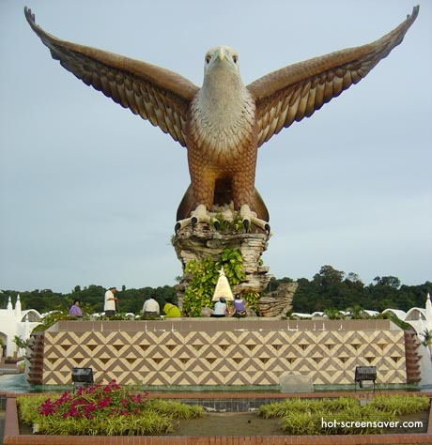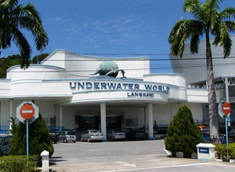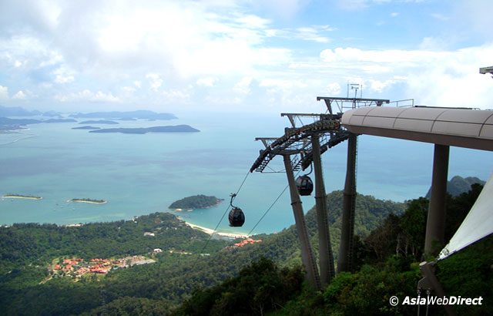

Hotel | Twin / Triple  (per person) | Child with extra bed | Child without bed | Single supplement additional
(3*) Bayview Hotel | RM 345.00 | RM 275.00 | RM 210.00 | RM 205.00
(3*+ ) Mutiara Burau Bay Beach Resort | RM 410.00 | RM 325.00 | RM 250.00 | RM 270.00
(4 *) Holiday Villa Beach Resort | RM 550.00 | RM 440.00 | RM 330.00 | RM 410.00
ITINERARY :

Day 1 ARRIVE LANGKAWI
Arrive Langkawi airport , proceed for a half day tour – visit Eagle Square, Batik, Mahsuri Memorial Park, Underwater World, after tour check in hotel.

Day 2 LANGKAWI (BREAKFAST)
Breakfast at hotel, free at own leisure

Day 3 LANGKAWI – OUT (BREAKFAST)
Breakfast at hotel, free until transfer to Airport for your departure

Package Inclusive :
~ Transfer in/out (seat in coach).
~ 2 Nights accommodation (Twin sharing).
~ 2 Hotel Breakfast.
~ Half day tour (seat in coach)

Package EXCLUDED :
~ Personal expenses
~ Domestic Air ticket
~ Tipping
~ Travel Insurance
~ Entrance fees.

REMARKS :
~ Rate is based on minimum 02 paxs and above.
~ Package is based on SIC basic.
~ Rates subject to change without any notice.
~Validity : Until March 2012.
~ All rate quoted base on RINGGIT MALAYSIA

PEAK SEASON SURCHARGE & COMPULSORY DINNER :-
~ Bayview Hotel additional surcharge @ RM 45.00 per room per night fall on 24 – 25 Dec ,
31 Dec – 01 Jan 2012 .
~Bayview Hotel school holiday surcharge @ RM 45.00 per room per night fall on 13 – 21 March 2012 .
~ Bayview Hotel compulsory Christmas & New year Eve Dinner @ RM 105.00 for adult & RM 65.00 per child .
~ Bayview hotel Chinese New Year compulsory dinner (01 dinner per stay) @ RM 80.00 per adult & RM 60.00 per child .
~ Holiday Villa Hotel additional surcharge @ RM 80.00 per room per night fall on 15 Dec 11 – 15 Jan 12 .
~ Holiday Villa Hotel compulsory Christmas eve dinner @ RM 175.00 per adult & RM 95.00 per child.
~ Holiday Villa Hotel compulsory New Year eve dinner @ RM 290.00 per adult & 155.00 per child .
~ Mutiara Burau Bay Hotel additional surcharge @ RM 100.00 per room per night fall on 20 Dec 11 – 14 Jan 12 .
~ Mutiara Burau Bay Hotel compulsory Christmas eve dinner @ RM 200.00 for adult & RM 100.00 for child .
~ Mutiara Buray Bay compulsory New Year Eve dinner @ RM 300.00 for adult & RM 150.00 for child .

